**Project Description: To Do List**

**1: Login Page:**

* Sign-up: To create a new account
* Forgot Password: To reset password in case you forgot.

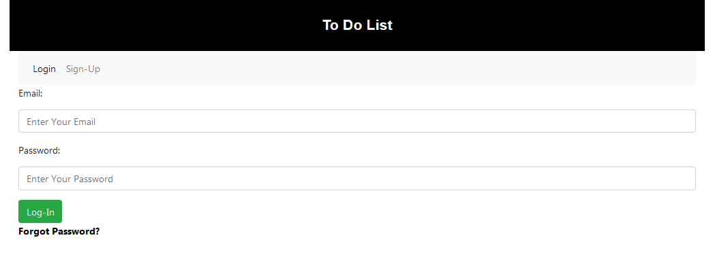

**2: Sign-Up Page:**

Here in sign-up page user can create an account to Login to the system

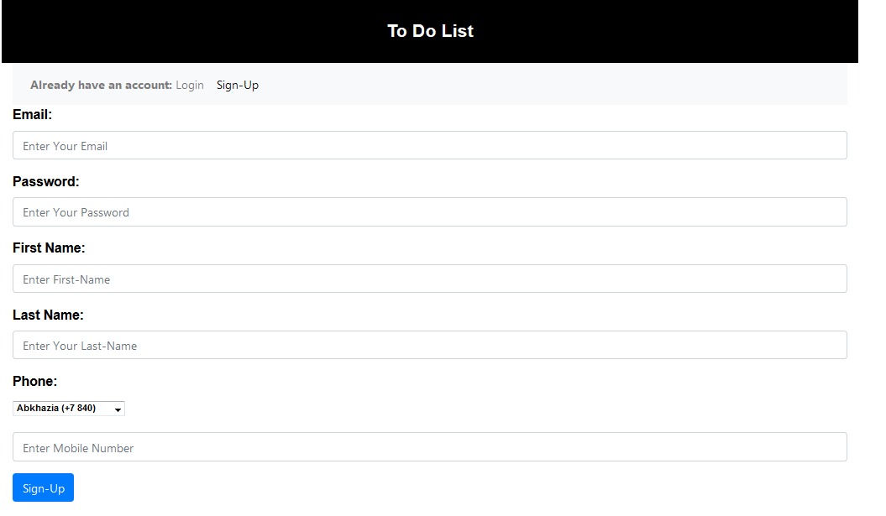

**3: Forgot Password:**

Enter Your Email address to recover password

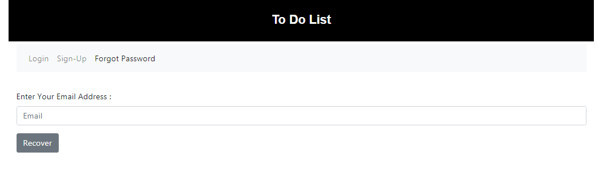

**4: To Do Menu:**

**4.1: For Single User:**

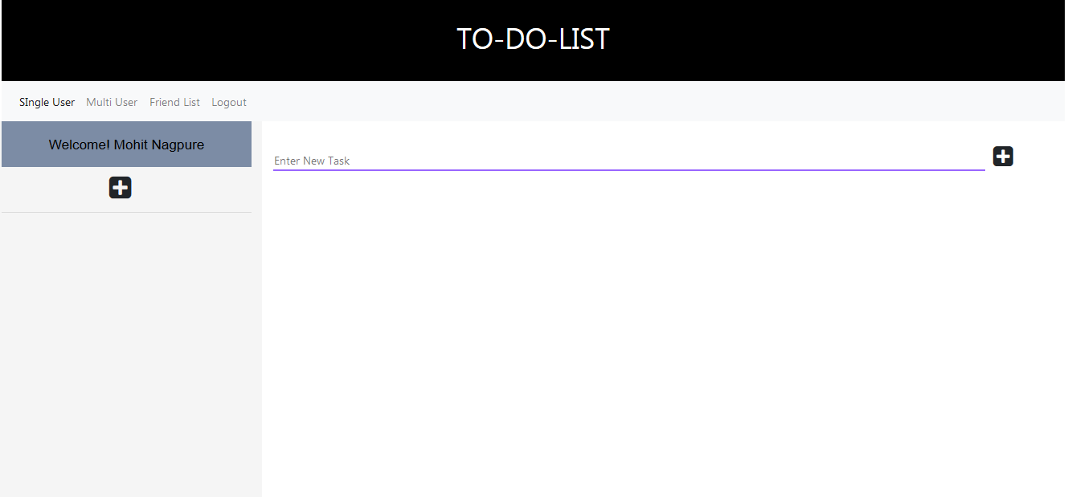

* To add a list click on “+” icon, it open a model in which user can add list.
* To add a task click on “+” icon present on the right of input field.

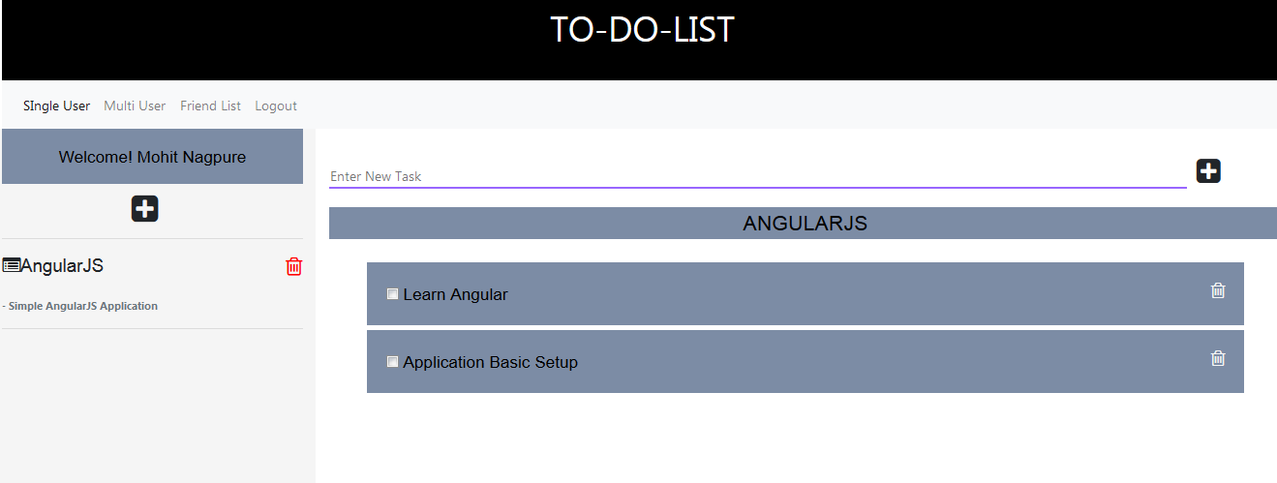

* Click on the list to add task to that particular list. “For ex: Angular JS”
* To add task, enter your task name in input field on the right side then click on “+” icon.
* On selecting the list, task name will be displayed on right side. Click on delete icon to delete list.

**4.2 Multi user**

* Click on multi user in Navigation bar to enter multi user room.
* The multi user function is similar to single user to do list but the task and list can be added or deleted by any user in the room.
* Real time to do create by using socketIO.

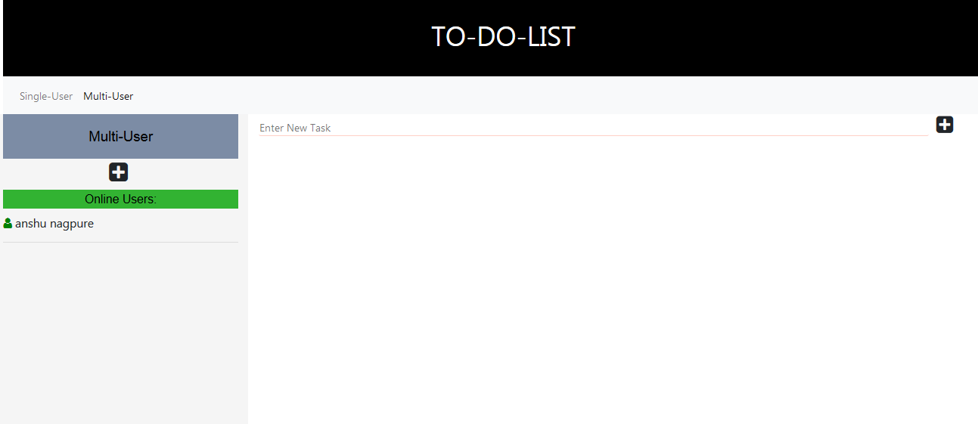

* Click on Single user in Navigation bar to go back to to-do-menu and single user room.

**5. Friend List**

* Click on Friend list in Navigation bar to open a friend list model.

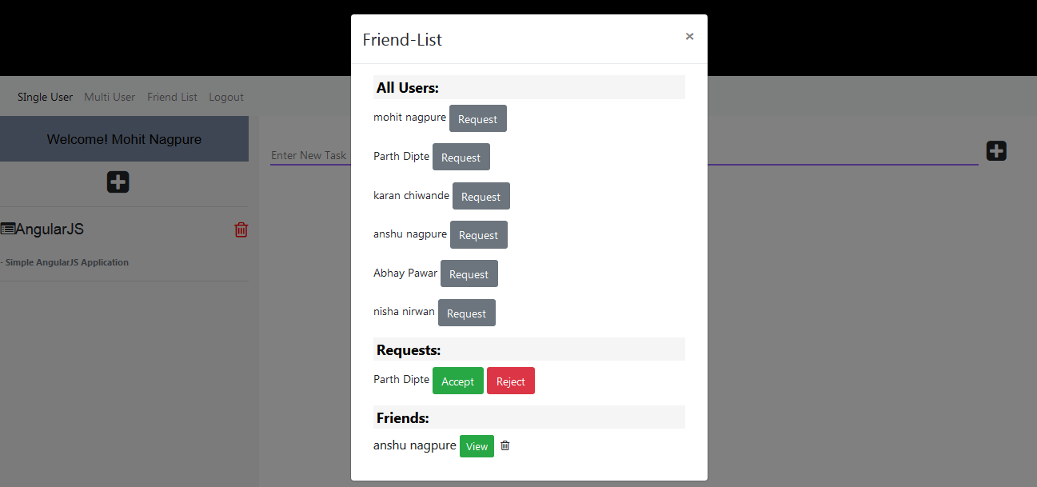

* All users using the app will be visible on all users section.
* Click on request button to send request to friend.
* In request section it will shows friend request by other users.
* If user is your friend it will shows in the friend section.
* Click on icon in friend section to unfriend user.
* You have to refresh the page to see changes in friend list and request list.

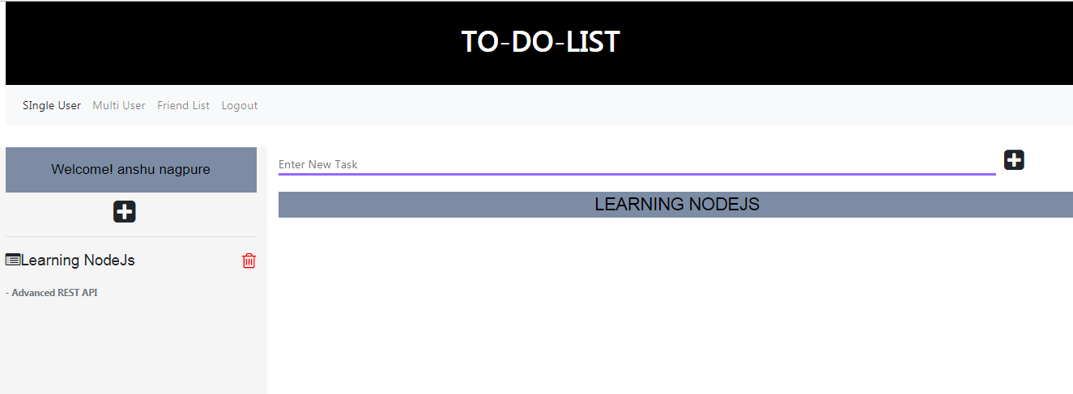

* Click on view button of friend to view the task of the friend.

**6. Log-out**

* Click on log-out in Navigation bar to log-out to the application